SEM Segmentation SOP
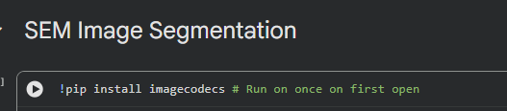
- If using Google Colab, run this cell first.

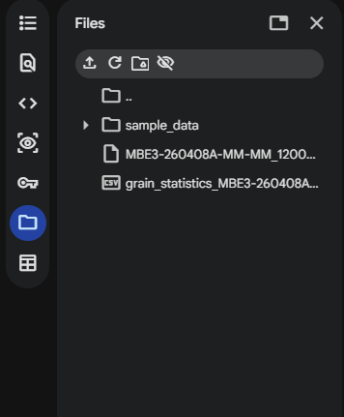
- Load the raw data into the notebook by dragging and dropping the file here. Click the folder icon if this panel does not appear.

- Update the image path here. You can get the path by right clicking the file and selecting Copy path.
- Run the next cell to load all metadata, then use Ctrl+F to search for “pixelwidth”.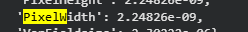
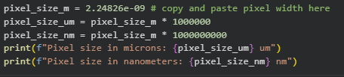

- Update the next cell by copying and pasting this pixel width.

- Now do image thresholding in the next cell.
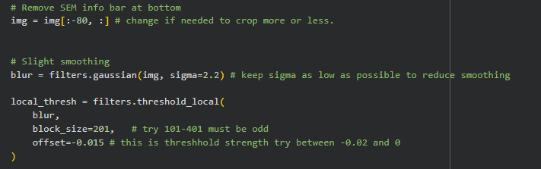

- The important parameters are the sigma of the Gaussian blur, the block size, and the offset. Recommended sigma values are between 1 and 3 (lower is usually better). The block size controls the size of the local threshold window. Recommended values are between 101 and 401, and the value must be odd. This value depends strongly on the size of the features. The offset controls the strength of the threshold. Recommended values are between -0.02 and 0.0. More negative values make the threshold stronger.
- A quick first pass could look like this: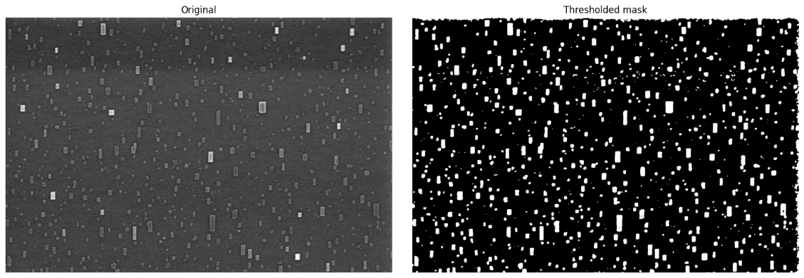

- Now clean the threshold mask in the next cell.
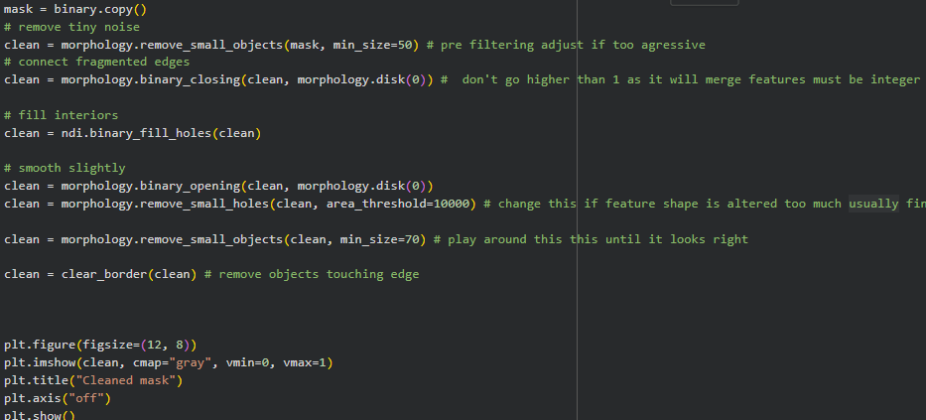

- Important parameters to adjust are the preprocessing small object filter, binary closing, and the final small object filter. Keep the preprocessing filter at about half the size of the final filter (larger minimum size values produce stronger filtering). Binary closing is only somewhat effective, so I usually keep it at 0. Finally, filter the remaining small objects. A decent cleaned mask could look like this.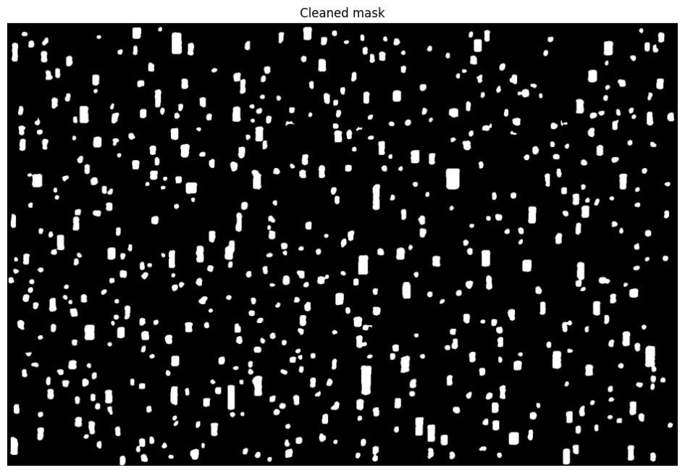
- Run the next cell, which gives the segmented features ImageJlike labels. These are the feature labels you will use when manually removing features.
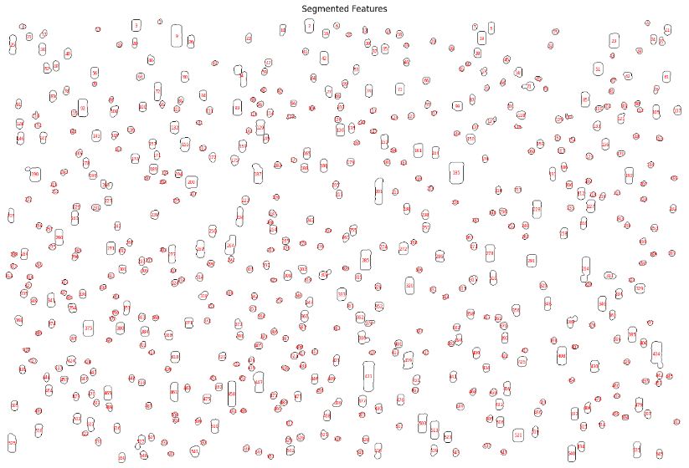
- Now run the next few code cells until you get here:
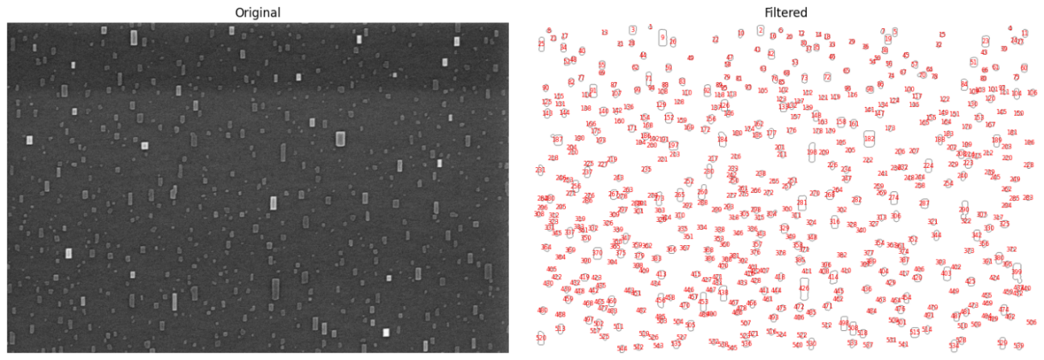
- Compare the filtered segmented features with the original SEM data and add any features to be manually filtered here 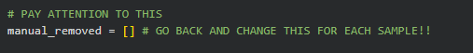 as a comma separated list. The values entered in this list must come from image labeled Segmented Features not either of the filtered images!
- If things look off, tweak the threshold and size filtering parameters from above. If things still look wrong, change the final filtering threshold. This should be a last resort these parameters work in most cases.
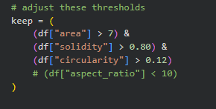
- Once segmentation is complete, run the remaining code cells. If the grain statistics do not appear, right c
- lick the small refresh button in the file menu and download the statistics from the menu.

